**A CRM APPLICATION FOR WHOLESALE RICE MILL**

Creating a CRM application for a wholesale rice mill involves several key components tailored to the unique needs of the business. Here’s a comprehensive outline of features and considerations:

**Key Features**

1. **Customer Management**
   * **Profile Creation**: Store detailed customer information (contact details, purchase history, preferences).
   * **Segmentation**: Categorize customers based on purchase volume, frequency, or location for targeted marketing.
2. **Order Management**
   * **Order Tracking**: Monitor the status of orders from placement to delivery.
   * **Invoicing**: Generate and send invoices directly from the CRM.
   * **Recurring Orders**: Set up automatic orders for regular customers.
3. **Inventory Management**
   * **Stock Levels**: Real-time tracking of rice stock, including different varieties and grades.
   * **Restocking Alerts**: Notifications for low stock levels to ensure timely replenishment.
4. **Sales Analytics**
   * **Reporting**: Generate reports on sales performance, customer buying patterns, and inventory turnover.
   * **Forecasting**: Use historical data to predict future sales trends and adjust inventory accordingly.
5. **Supplier Management**
   * **Supplier Profiles**: Maintain information about suppliers, including pricing and reliability.
   * **Purchase Orders**: Manage orders to suppliers and track deliveries.
6. **Marketing Tools**
   * **Email Campaigns**: Create and send promotional emails to customers.
   * **Loyalty Programs**: Implement rewards programs to encourage repeat purchases.
7. **Communication Tools**
   * **Messaging**: Integrated chat or messaging for customer inquiries and support.
   * **Call Logging**: Record customer calls for better service and follow-up.
8. **User Roles and Permissions**
   * **Access Control**: Define roles for employees (sales, inventory, management) to control access to sensitive information.
9. **Mobile Access**
   * **Mobile App**: Enable sales representatives to access the CRM on-the-go, updating orders and checking inventory.
10. **Integration Capabilities**
    * **Accounting Software**: Integrate with popular accounting tools for financial management.
    * **E-commerce Platforms**: Connect with online sales channels if applicable.

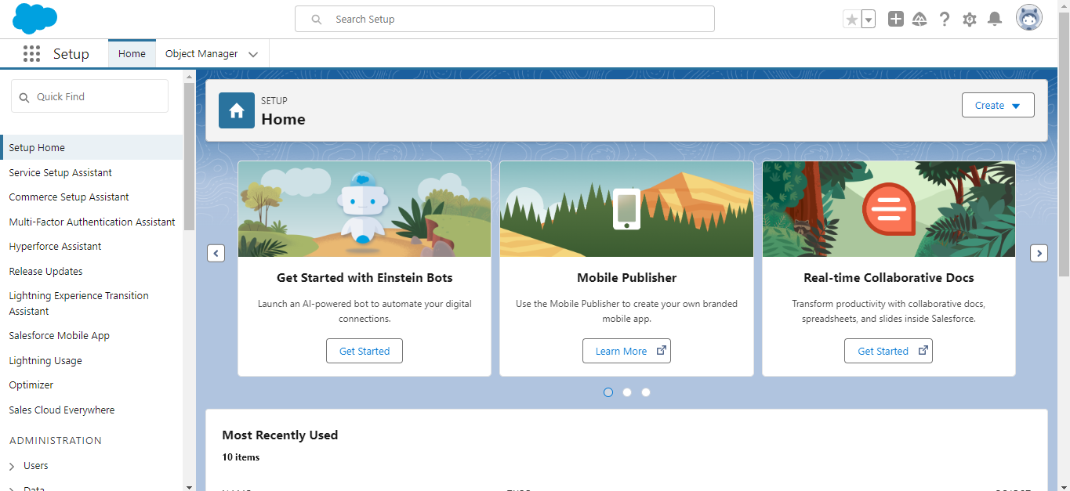

Fig:Salesforce Platform

**What Is an Object?**

Salesforce objects are database tables that permit you to store data that is specific to an organization. What are the types of Salesforce objects

Salesforce objects are of two types:

Standard Objects: Standard objects are the kind of objects that are provided by salesforce.com such as users, contracts, reports, dashboards, etc.

Custom Objects: Custom objects are those objects that are created by users. They supply information that is unique and essential to their organization. They are the heart of any application and provide a structure for sharing data.

To create a Supplier object, you can define a class or model that represents the supplier's data in the CRM application. Below is a basic structure for a Supplier object in Python, which can be used in a larger CRM application. This object will include details like supplier name, contact information, address, product type, and more.

**Key Elements of the Supplier Object:**

1. **Supplier ID**: A unique identifier for each supplier.
2. **Name**: The supplier’s company name.
3. **Contact Information**: Including the contact person's name, phone, and email.
4. **Address**: The physical address of the supplier (useful for logistics).
5. **Products Supplied**: A list of the products that the supplier provides, which could be rice types such as raw rice, parboiled rice, etc.
6. **Rating**: A rating system to measure the reliability and quality of the supplier.
7. **Payment Terms**: The agreed-upon payment terms, such as "Net 30" or "Prepaid".

**Steps to Create a Supplier Object in Salesforce:**

1. **Log in to Salesforce**: First, log into your Salesforce organization.
2. **Navigate to Object Manager**:
   * Click on the **Gear icon** (⚙️) in the upper-right corner.
   * Click on **Setup**.
   * In the left-hand sidebar, under **Objects and Fields**, click **Object Manager**.
3. **Create a New Custom Object**:
   * Click on the **Create** button in the upper-right corner of the Object Manager page.
   * Select **Custom Object**.
4. **Define the Supplier Object**:
   * **Label**: Supplier
   * **Plural Label**: Suppliers
   * **Object Name**: Supplier
   * **Record Name**: Supplier Name (you can choose Auto Number or Text. Text is recommended if you want to manually name your suppliers).
   * **Data Type**: Text
   * **Allow Reports**: Check this box if you want to generate reports related to suppliers.
   * **Allow Activities**: Check this if you want to log calls, tasks, and events related to suppliers.
   * **Track Field History**: You can enable this if you want to track changes to certain fields.
5. **Save**: Click **Save** to create the Supplier object.

**Creating Fields for Supplier Object:**

Now that you have created the Supplier object, you need to add fields that define supplier-specific information.

1. **Supplier ID (Auto Number)**:
   * **Field Type**: Auto Number
   * **Field Label**: Supplier ID
   * **Display Format**: SUP-{0000} (This will generate Supplier IDs like SUP-0001, SUP-0002, etc.)
   * **Starting Number**: 1
2. **Contact Name (Text)**:
   * **Field Type**: Text
   * **Field Label**: Contact Name
   * **Length**: 255
3. **Phone (Phone)**:
   * **Field Type**: Phone
   * **Field Label**: Contact Phone
4. **Email (Email)**:
   * **Field Type**: Email
   * **Field Label**: Contact Email
5. **Address (Text Area)**:
   * **Field Type**: Text Area (Long)
   * **Field Label**: Address
   * **Length**: 255
6. **Products Supplied (Picklist or Multi-Select Picklist)**:
   * **Field Type**: Multi-Select Picklist (if suppliers provide multiple products)
   * **Field Label**: Products Supplied
   * **Values**: (e.g., "Raw Rice", "Broken Rice", "Parboiled Rice", "Brown Rice")
7. **Rating (Number)**:
   * **Field Type**: Number
   * **Field Label**: Rating
   * **Length**: 2 (e.g., rating from 1-5)
   * **Decimal Places**: 1 (e.g., 4.5 rating)
8. **Payment Terms (Picklist)**:
   * **Field Type**: Picklist
   * **Field Label**: Payment Terms
   * **Values**: (e.g., "Net 30", "Prepaid", "Net 60", "Upon Delivery")
9. **Supplier Type (Picklist)**:
   * **Field Type**: Picklist
   * **Field Label**: Supplier Type
   * **Values**: (e.g., "Domestic", "International")
10. **Contract Start Date (Date)**:
    * **Field Type**: Date
    * **Field Label**: Contract Start Date
11. **Contract End Date (Date)**:
    * **Field Type**: Date
    * **Field Label**: Contract End Date
12. **Status (Picklist)**:
    * **Field Type**: Picklist
    * **Field Label**: Status
    * **Values**: (e.g., "Active", "Inactive", "Prospect")

**Example Record Creation for Supplier:**

After creating the Supplier object and the necessary fields, users in Salesforce can begin creating records for each supplier.

To create a new supplier record:

1. Go to the **App Launcher** (the waffle icon) and search for "Suppliers."
2. Click **New** to create a new supplier record.
3. Fill in the relevant fields:
   * Supplier ID: Automatically generated (e.g., SUP-0001)
   * Contact Name: John Doe
   * Phone: +1234567890
   * Email: [john.doe@supplier.com](mailto:john.doe@supplier.com)
   * Address: 123 Grain Street, Farmville
   * Products Supplied: Raw Rice, Parboiled Rice
   * Rating: 4.5
   * Payment Terms: Net 30
   * Supplier Type: Domestic
   * Contract Start Date: 01/01/2024
   * Contract End Date: 01/01/2025
   * Status: Active

The Supplier object in Salesforce will allow you to manage supplier relationships, keep track of their contact and product details, and automate workflows related to supplier management. You can enhance the CRM functionality for a wholesale rice mill or any other business, integrating the supplier details with other standard Salesforce objects like Opportunities or Orders.

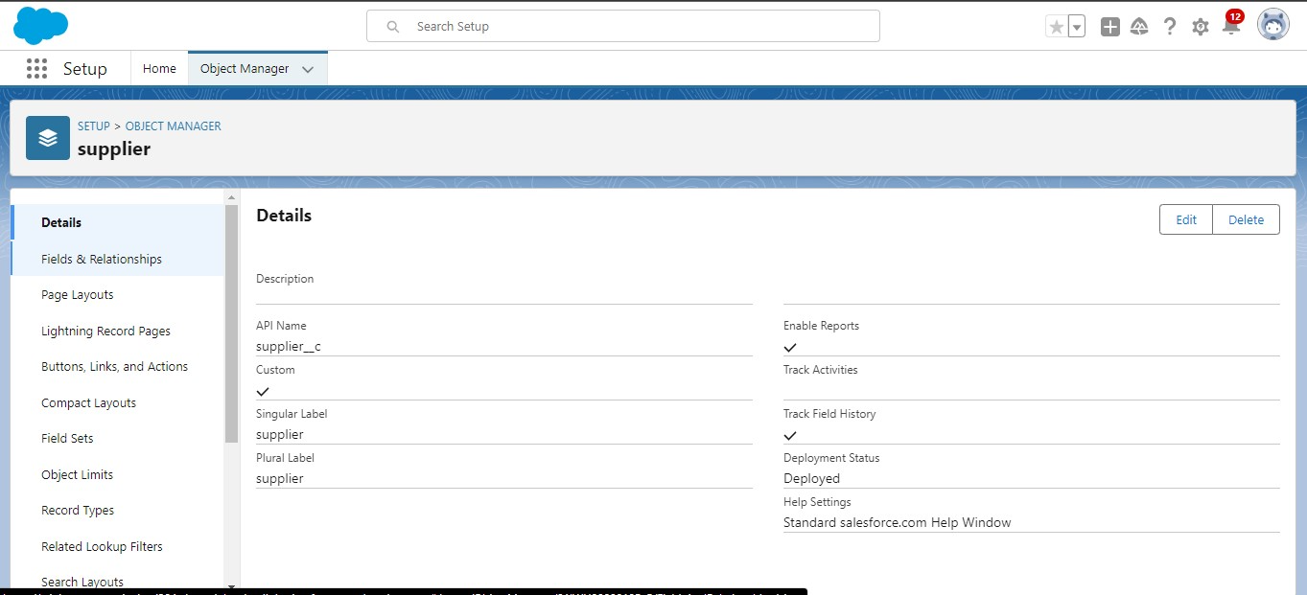

Fig : Object

To create the Rice Mill, Consumer, and Rice Details objects in Salesforce, you will follow similar steps as when creating the Supplier object. Each object will have its own fields to capture relevant data. Here's how to define each object and the associated fields.

**1. Rice Mill Object**

**Steps to Create Rice Mill Object:**

1. **Navigate to Object Manager**.
   * Click on **Setup** > **Object Manager**.
   * Click on **Create** > **Custom Object**.
2. **Define the Rice Mill Object**:
   * **Label**: Rice Mill
   * **Plural Label**: Rice Mills
   * **Object Name**: Rice_Mill
   * **Record Name**: Rice Mill Name (set as Text for manual naming).
   * **Allow Reports**: Checked.
   * **Allow Activities**: Checked.
   * **Track Field History**: Optional.
3. **Save** the object.

**Fields for Rice Mill Object:**

1. **Mill ID (Auto Number)**:
   * **Field Type**: Auto Number
   * **Field Label**: Mill ID
   * **Display Format**: MILL-{0000}
   * **Starting Number**: 1
2. **Mill Location (Text)**:
   * **Field Type**: Text
   * **Field Label**: Mill Location
   * **Length**: 255
3. **Capacity (Number)**:
   * **Field Type**: Number
   * **Field Label**: Mill Capacity (tons per day)
   * **Length**: 10
   * **Decimal Places**: 2
4. **Contact Person (Text)**:
   * **Field Type**: Text
   * **Field Label**: Contact Person
   * **Length**: 100
5. **Contact Phone (Phone)**:
   * **Field Type**: Phone
   * **Field Label**: Contact Phone
6. **Contact Email (Email)**:
   * **Field Type**: Email
   * **Field Label**: Contact Email
7. **Status (Picklist)**:
   * **Field Type**: Picklist
   * **Field Label**: Status
   * **Values**: Active, Inactive

**2. Consumer Object**

**Steps to Create Consumer Object:**

1. **Navigate to Object Manager**.
   * Go to **Setup** > **Object Manager**.
   * Click **Create** > **Custom Object**.
2. **Define the Consumer Object**:
   * **Label**: Consumer
   * **Plural Label**: Consumers
   * **Object Name**: Consumer
   * **Record Name**: Consumer Name (set as Text for manual naming).
   * **Allow Reports**: Checked.
   * **Allow Activities**: Checked.
   * **Track Field History**: Optional.
3. **Save** the object.

**Fields for Consumer Object:**

1. **Consumer ID (Auto Number)**:
   * **Field Type**: Auto Number
   * **Field Label**: Consumer ID
   * **Display Format**: CONS-{0000}
   * **Starting Number**: 1
2. **Consumer Type (Picklist)**:
   * **Field Type**: Picklist
   * **Field Label**: Consumer Type
   * **Values**: Retailer, Distributor, Individual
3. **Contact Person (Text)**:
   * **Field Type**: Text
   * **Field Label**: Contact Person
   * **Length**: 100
4. **Contact Phone (Phone)**:
   * **Field Type**: Phone
   * **Field Label**: Contact Phone
5. **Contact Email (Email)**:
   * **Field Type**: Email
   * **Field Label**: Contact Email
6. **Billing Address (Text Area)**:
   * **Field Type**: Text Area
   * **Field Label**: Billing Address
   * **Length**: 255
7. **Shipping Address (Text Area)**:
   * **Field Type**: Text Area
   * **Field Label**: Shipping Address
   * **Length**: 255
8. **Payment Terms (Picklist)**:
   * **Field Type**: Picklist
   * **Field Label**: Payment Terms
   * **Values**: Net 30, Prepaid, COD

**3. Rice Details Object**

**Steps to Create Rice Details Object:**

1. **Navigate to Object Manager**.
   * Go to **Setup** > **Object Manager**.
   * Click **Create** > **Custom Object**.
2. **Define the Rice Details Object**:
   * **Label**: Rice Detail
   * **Plural Label**: Rice Details
   * **Object Name**: Rice_Detail
   * **Record Name**: Rice Detail (set as Text for manual naming).
   * **Allow Reports**: Checked.
   * **Allow Activities**: Checked.
   * **Track Field History**: Optional.
3. **Save** the object.

**Fields for Rice Details Object:**

1. **Rice ID (Auto Number)**:
   * **Field Type**: Auto Number
   * **Field Label**: Rice ID
   * **Display Format**: RICE-{0000}
   * **Starting Number**: 1
2. **Rice Type (Picklist)**:
   * **Field Type**: Picklist
   * **Field Label**: Rice Type
   * **Values**: Raw Rice, Parboiled Rice, Brown Rice, Broken Rice
3. **Grade (Picklist)**:
   * **Field Type**: Picklist
   * **Field Label**: Rice Grade
   * **Values**: A-Grade, B-Grade, C-Grade
4. **Stock Availability (Number)**:
   * **Field Type**: Number
   * **Field Label**: Stock Availability (in tons)
   * **Length**: 10
   * **Decimal Places**: 2
5. **Price per Ton (Currency)**:
   * **Field Type**: Currency
   * **Field Label**: Price per Ton
   * **Length**: 16
   * **Decimal Places**: 2
6. **Harvest Year (Number)**:
   * **Field Type**: Number
   * **Field Label**: Harvest Year
   * **Length**: 4 (e.g., 2024)
7. **Supplier (Lookup)**:
   * **Field Type**: Lookup Relationship
   * **Field Label**: Supplier
   * **Related To**: Supplier

**Object Relationships:**

* **Rice Mill to Supplier**: You can create a lookup relationship between Rice Mill and Supplier objects, associating a supplier with the rice mill for inventory purposes.
* **Rice Details to Supplier**: The Rice Details object can have a lookup relationship to the Supplier object, showing where each rice product is sourced from.
* **Rice Details to Rice Mill**: You can also create a lookup relationship between Rice Details and Rice Mill, linking the available rice types with specific mills.

**Tabs**

What is Tab : A tab is like a user interface that is used to build records for objects and to view the records in the objects.

Types of Tabs:

Custom Tabs

Custom object tabs are the user interface for custom applications that you build in salesforce.com. They look and behave like standard salesforce.com tabs such as accounts, contacts, and opportunities.

Web Tabs

Web Tabs are custom tabs that display web content or applications embedded in the salesforce.com window. Web tabs make it easier for your users to quickly access content and applications they frequently use without leaving the salesforce.com application.

Visualforce Tabs

Visualforce Tabs are custom tabs that display a Visualforce page. Visualforce tabs look and behave like standard salesforce.com tabs such as accounts, contacts, and opportunities.

Lightning Component Tabs

Lightning Component tabs allow you to add Lightning components to the navigation menu in Lightning Experience and the mobile app.

Lightning Page Tabs

Lightning Page Tabs let you add Lightning Pages to the mobile app navigation menu.

Lightning Page tabs don't work like other custom tabs. Once created, they don't show up on the All Tabs page when you click the Plus icon that appears to the right of your current tabs. Lightning Page tabs also don't show up in the Available Tabs list when you customize the tabs for your apps.

To create a **Custom Tab** in Salesforce for your custom objects (like Supplier, Rice Mill, Consumer, or Rice Details), follow these steps. A tab allows users to easily access the data in custom objects via the Salesforce user interface.

**Steps to Create a Custom Tab in Salesforce:**

1. **Navigate to Setup**:
   * Click on the **Gear icon** (⚙️) in the upper-right corner of your Salesforce screen.
   * Click **Setup**.
2. **Find Tabs in the Setup Menu**:
   * In the **Quick Find** box on the left side, type "Tabs."
   * Click on **Tabs** under the **User Interface** section.
3. **Create a New Custom Tab**:
   * Scroll to the **Custom Object Tabs** section.
   * Click the **New** button.
4. **Select the Object**:
   * From the **Object** dropdown, select the custom object for which you want to create a tab (e.g., Supplier, Rice Mill, Consumer, Rice Details).
5. **Choose a Tab Style**:
   * Salesforce will present a set of icons and colors for the tab. You can choose an appropriate tab style that represents your custom object.
   * If none of the available icons fit, you can upload a custom icon (optional).
6. **Enter a Tab Label**:
   * The **Tab Label** will default to the singular name of your object, but you can edit it if needed.
7. **Define Tab Visibility**:
   * **Tab Visibility**: Specify which user profiles will have access to this tab. You can set it to "Default On," "Default Off," or "Hidden" for each profile.
     + **Default On**: The tab will be visible in the app for that profile.
     + **Default Off**: The tab will be available, but not shown by default (users can manually add it to their navigation).
     + **Hidden**: The tab will be hidden for that profile.
8. **Add to Applications**:
   * Choose which Salesforce apps you want to include this tab in (e.g., Sales, Service, Custom Apps). This allows users working in specific applications to see this tab as part of their navigation bar.
9. **Save** the Custom Tab.

**Example:**

If you're creating a custom tab for the Rice Mill object:

* Select the Rice Mill object in step 4.
* Choose an icon that represents a factory, warehouse, or product (or upload your own icon).
* Set the visibility for all relevant user profiles and add it to any custom or standard apps you want to use.

**Using the Custom Tab:**

Once created, the custom tab will be available in the Salesforce navigation bar for the specified profiles and apps. Users can click on the tab to:

* View a list of records from the custom object.
* Create new records.
* Search for existing records.

Custom tabs in Salesforce allow easy access to your custom object data. Once you’ve created the necessary objects (like Supplier, Rice Mill, Consumer, or Rice Details), creating a custom tab will allow users to interact with these objects directly from the main navigation.

**The Lightning App**

An app is a collection of items that work together to serve a particular function. In Lightning Experience, Lightning apps give your users access to sets of objects, tabs, and other items all in one convenient bundle in the navigation bar.

Lightning apps let you brand your apps with a custom color and logo. You can even include a utility bar and Lightning page tabs in your Lightning app. Members of your org can work more efficiently by easily switching between apps.

To create a **Lightning App** in Salesforce, which organizes your custom objects, tabs, and other tools into a unified interface, follow these steps. A Lightning App helps users interact with your custom objects like Supplier, Rice Mill, Consumer, and Rice Details 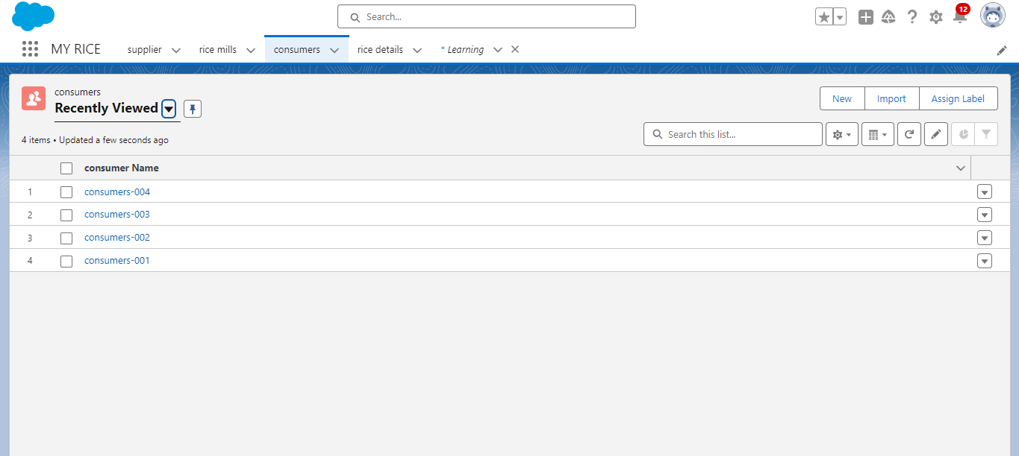

Fig :Lightning App

**Steps to Create a Lightning App:**

1. **Navigate to Setup**:
   * Click the **Gear icon** (⚙️) in the top right corner of the Salesforce page.
   * Click **Setup**.
2. **Search for App Manager**:
   * In the **Quick Find** box (on the left-hand side), type "App Manager."
   * Click **App Manager** under the **Apps** section.
3. **Create a New Lightning App**:
   * In the **App Manager** page, click the **New Lightning App** button (in the top right).
4. **Define the App**:
   * **App Name**: Enter a name for your app (e.g., Rice Mill Management).
   * **Developer Name**: This will be auto-generated but can be customized.
   * **Description**: Optionally, enter a description to explain what the app does.
   * **App Branding** (Optional): You can upload a custom logo and choose the app’s color scheme.
   * Click **Next**.
5. **App Options**:
   * **Navigation Style**: Choose **Standard Navigation** (which is typical for most apps).
   * **App Visibility**: Choose whether the app should be available on both desktop and phone.
   * **Setup the App Bar**: Enable **Setup** or **Utility Bar** features if needed.
   * Click **Next**.
6. **Choose Utility Items** (Optional):
   * If you want to add utility components to the app, like a calculator or notes, you can add them here. These appear at the bottom of the app.
   * Click **Next** after selecting or skip this step.
7. **Select the Navigation Items (Tabs)**:
   * **Primary Tabs**: Choose the custom and standard objects that should be visible as navigation items for users in the app.
   * Click the **Add** button to include objects like Supplier, Rice Mill, Consumer, Rice Details, etc.
   * You can also add other standard tabs like **Reports**, **Dashboards**, **Chatter**, etc.
   * Rearrange the order of the tabs by dragging and dropping them.
   * Click **Next** once you have selected the tabs.
8. **Assign User Profiles**:
   * Select which user profiles should have access to this Lightning App (e.g., System Administrator, Standard User, etc.).
   * You can also choose to make the app visible only to specific profiles.
   * Click **Next**.
9. **Review and Finish**:
   * Review your app’s details, and if everything looks good, click **Finish**.

A **Lightning App** in Salesforce helps you create a streamlined interface for specific business needs, like managing rice mills, suppliers, consumers, and rice details. By carefully selecting which objects and tools are included in the app, you can improve user experience and efficiency.

**Fields**

When we talk about Salesforce, Fields represent the data stored in the columns of a relational database. It can also hold any valuable information that you require for a specific object. Hence, the overall searching, deletion, and editing of the records become simpler and quicker.

**Types of Fields**

Standard Fields

Custom Fields

Standard Fields:

As the name suggests, the Standard Fields are the predefined fields in Salesforce that perform a standard task. The main point is that you can’t simply delete a Standard Field until it is a non-required standard field. Otherwise, users have the option to delete them at any point from the application freely. Moreover, we have some fields that you will find common in every Salesforce application. They are,

1. Created By

2. Owner

3. Last Modified

4. Field Made During object Creation

Custom Fields:

On the other side of the coin, Custom Fields are highly flexible, and users can change them according to requirements. Moreover, each organizer or company can use them if necessary. It means you need not always include them in the records, unlike Standard fields. Hence, the final decision depends on the user, and he can add/remove Custom Fields of any given form.

To create a **Number Field** in the Rice Details object in Salesforce, follow these steps:

**Steps to Create a Number Field in the Rice Details Object:**

1. **Navigate to Object Manager**:
   * Click on the **Gear icon** (⚙️) in the upper-right corner of the screen.
   * Click on **Setup**.
   * In the **Quick Find** box, type **Object Manager** and select **Object Manager** from the list.
2. **Select the Rice Details Object**:
   * In **Object Manager**, find and click on the **Rice Details** object.
   * You can search for Rice Details using the search bar in the top right.
3. **Create a New Field**:
   * In the Rice Details object page, click on the **Fields & Relationships** tab.
   * Click the **New** button in the top right.
4. **Choose Field Type**:
   * Select **Number** as the field type.
   * Click **Next**.
5. **Configure the Number Field**:
   * **Field Label**: Enter a label for the field (e.g., "Stock Quantity" or "Weight in Tons").
   * **Field Name**: This will automatically be populated based on the field label, but you can customize it if needed.
   * **Length**: Enter the total number of digits that the field can store (e.g., 10).
   * **Decimal Places**: If applicable, specify how many decimal places the field should allow (e.g., 2 for values like 10.25 tons).
6. **Field-Level Security**:
   * Choose the user profiles that can view or edit this field.
   * If the field should be visible to all users, select the **Visible** checkbox for all profiles.
   * Click **Next**.
7. **Add to Page Layout**:
   * Specify whether you want this field to be automatically added to your current page layout for the Rice Details object.
   * Ensure it's selected to be included on all necessary layouts.
   * Click **Save**.

**Page layouts**

Page Layout in Salesforce allows us to customize the design and organize detail and edit pages of records in Salesforce. Page layouts can be used to control the appearance of fields, related lists, and custom links on standard and custom objects' detail and edit pages.

Creating a **Page Layout** in Salesforce allows you to customize how fields, sections, and related lists are displayed for a specific object, such as the Rice Details object. You can control what information users see when they view or edit a record.

**Steps to Create and Customize a Page Layout:**

1. **Navigate to Object Manager**:
   * Click the **Gear icon** (⚙️) in the upper-right corner of Salesforce.
   * Click on **Setup**.
   * In the **Quick Find** box, type **Object Manager**.
   * Click on **Object Manager**.
2. **Select the Object**:
   * Search for the Rice Details object (or the object for which you want to create the page layout) in the list.
   * Click on the **Rice Details** object.
3. **Go to Page Layouts**:
   * In the left-hand menu, click on **Page Layouts**.
   * This will show a list of existing page layouts.
4. **Create a New Page Layout**:
   * Click the **New** button to create a new layout.
   * You can either:
     + **Clone** an existing layout: This allows you to create a copy of an existing layout and modify it.
     + **Create a new layout from scratch**.
5. **Define the Layout**:
   * **Layout Name**: Give your layout a name like Rice Details Layout.
   * **Save** to continue.
6. **Add Fields to the Layout**:
   * You will now be taken to the page layout editor where you can drag and drop elements.
   * **Fields**: Drag fields from the top palette (Field Section) onto the layout. Place them in the desired sections of the layout. For example:
     + **Rice Type**
     + **Stock Quantity** (the number field you created earlier)
     + **Price per Ton**
     + **Harvest Year**
   * **Sections**: You can also create new sections by dragging the "Section" element onto the layout. For example, create a section for "Pricing Information" and another for "Inventory Details."
7. **Add Related Lists** (Optional):
   * You can also add **Related Lists** to show associated records from related objects (e.g., Supplier, Rice Mill).
   * Drag the **Related List** component onto the layout to show any related objects or child objects.
8. **Adjust Layout Settings**:
   * You can rearrange the fields, make fields read-only, or required by clicking on the **wrench icon** beside each field.
   * To make a field required on the layout, click on the field, select the **Required** checkbox, and save.
9. **Add Custom Buttons or Links** (Optional):
   * If you need, you can also add custom buttons or links by dragging them from the top palette to the button bar section of the layout.
10. **Save the Layout**:
    * Once you have configured the layout, click **Save**.
11. **Assign the Layout** to Profiles (Optional):
    * After saving, Salesforce will prompt you to assign the new page layout to specific profiles (like System Administrator, Standard User, etc.).
    * You can either assign it immediately or come back later to do it.

**Profiles:**

A profile is a group/collection of settings and permissions that define what a user can do in salesforce. Profile controls “Object permissions, Field permissions, User permissions, Tab settings, App settings, Apex class access, Visualforce page access, Page layouts, Record Types, Login hours & Login IP ranges. You can define profiles by the user's job function. For example System Administrator, Developer, Sales Representative.

Types of profiles in salesforce

Standard profiles:

By default salesforce provides below standard profiles.

Contract Manager

Read Only

Marketing User

Solutions Manager

Standard User

System Administrator.

We cannot deleted standard ones

Each of these standard ones includes a default set of permissions for all of the standard objects available on the platform.

Custom Profiles:

Custom ones defined by us.

They can be deleted if there are no users assigned with that particular one.

In Salesforce, **Profiles** control the level of access a user has to various objects, fields, tabs, and other features. If you want to create specific profiles like **Owner Profile**, **Employer Profile**, and **Worker Profile** for your rice mill system, you can do this by cloning existing profiles and then customizing the permissions to suit each user role.

**Steps to Create Custom Profiles in Salesforce:**

**1. Navigate to Profiles:**

* Click on the **Gear icon** (⚙️) in the upper-right corner.
* Click on **Setup**.
* In the **Quick Find** box, type **Profiles**.
* Click on **Profiles** under the **Users** section.

**2. Clone an Existing Profile:**

* In the list of profiles, find a profile that closely matches the access level you need for the new profile (e.g., **Standard User** or **System Administrator**).
* Click on the **Clone** link next to that profile.

**3. Define the Profile Name:**

* Enter a name for your new profile (e.g., **Owner Profile**, **Employer Profile**, or **Worker Profile**).
* Customize the **Profile Name** and description, so it's easy to distinguish between the different user roles.
* Click **Save**.

**4. Customize Profile Permissions:**

After cloning the profile, you’ll need to edit the permissions to match the responsibilities of each role (Owner, Employer, Worker).

* **Object Permissions**:
  + Scroll down to the **Standard Object Permissions** and **Custom Object Permissions** sections.
  + Grant appropriate permissions to the Supplier, Rice Mill, Consumer, and Rice Details objects for each profile:
    - **Read**: Allows the user to view the object records.
    - **Create**: Allows the user to create new records.
    - **Edit**: Allows the user to edit records.
    - **Delete**: Allows the user to delete records.
    - **View All**: Allows the user to view all records, not just ones they own.
    - **Modify All**: Allows the user to modify all records, not just ones they own.
* Example Permissions:
  + **Owner Profile**: Full access (Read, Create, Edit, Delete) to all objects.
  + **Employer Profile**: Full access to Rice Mill and Supplier, but maybe only read-only or limited access to Consumer and Rice Details.
  + **Worker Profile**: Read-only access to most objects, and possibly Create access to Rice Details (for inputting inventory data).
* **Field-Level Security**:
  + Scroll down to the **Field-Level Security** section and configure access to specific fields. For instance, you might want only Owners to view or edit sensitive fields like pricing information, while Workers only have access to stock quantities.
* **Tab Settings**:
  + Set the **Tab Visibility** for each profile:
    - **Default On**: Tab will appear in the navigation bar.
    - **Default Off**: Tab will be hidden but accessible if needed.
    - **Hidden**: Tab will not be visible to the user.
* **Record Types**:
  + If you’re using multiple **Record Types** for an object, assign the appropriate record types to each profile based on what types of records each profile should be able to create or access.
* **Page Layouts**:
  + Assign appropriate **Page Layouts** to each profile based on the custom layouts you’ve created (e.g., a different layout for Owner vs. Worker).
* **App Settings**:
  + Specify which **Lightning Apps** are available for each profile. For example, the **Rice Mill Management App** could be visible to the **Owner** and **Employer** profiles, while workers may have access to a simplified app.

**5. Save the Profile:**

* Once you’ve adjusted the permissions, click **Save**.

**Custom Profiles:**

Custom ones defined by us.

They can be deleted if there are no users assigned with that particular one.

Role & Role Hierarchy

A role in Salesforce defines a user's visibility access at the record level. Roles may be used to specify the types of access that people in your Salesforce organization can have to data. Simply put, it describes what a user could see within the Salesforce organization.

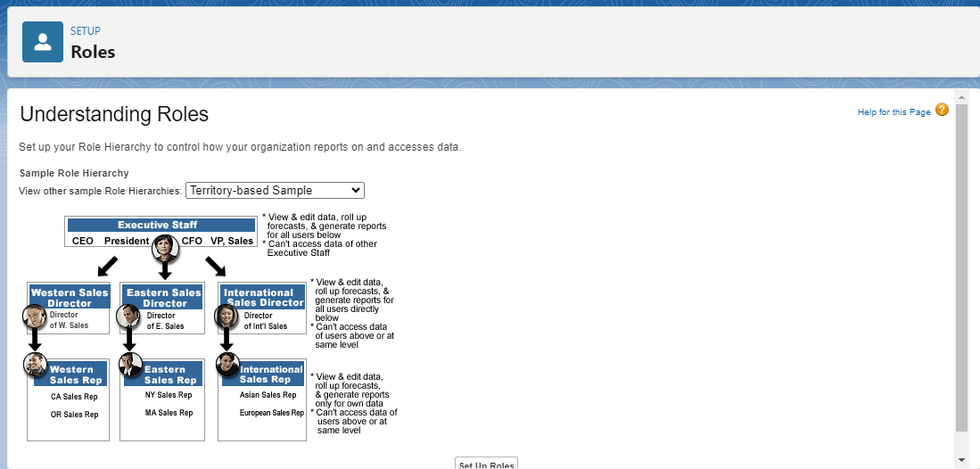

Fig;Roles

**Steps to Create a Role in Salesforce:**

1. **Navigate to Setup**:
   * Click on the **Gear icon** (⚙️) in the upper-right corner of the screen.
   * Click on **Setup**.
   * In the **Quick Find** box, type **Roles**.
   * Select **Roles** under the **Users** section.
2. **Open the Role Hierarchy**:
   * In the **Roles** page, you will see the existing role hierarchy for your organization.
   * If no hierarchy exists, you’ll need to build it from scratch.
3. **Add a New Role**:
   * Click the **Set Up Roles** button.
   * In the **Role Hierarchy** page, click the **Add Role** button at the appropriate level where you want to create your role.
4. **Configure the Role**:
   * **Role Label**: Enter the name of the role (e.g., Owner or Employer).
   * **Role Name**: This will be auto-generated based on the Role Label.
   * **Parent Role**: Choose the parent role in the hierarchy. For example:
     + If you are creating the Owner role and want it to be at the top, you may set it as a root-level role (no parent).
     + For the Employer role, you may set the Owner role as the parent, indicating that Employers report to Owners.
   * **Specify the Role’s Level**: You may leave it as default, but if you need further adjustments for record access, you can define the role's place in the hierarchy.
   * **Description**: Add a description (e.g., “This role manages rice mill operations” for Employer).
   * **Opportunity Access** (optional): You can specify whether users in this role have access to opportunities owned by their subordinates.
5. **Click Save** to Create the Role.

**Users**

A user is anyone who logs in to Salesforce. Users are employees at your company, such as sales reps, managers, and IT specialists, who need access to the company's records. Every user in Salesforce has a user account. The user account identifies the user, and the user account settings determine what features and records the user can access.

**Create User**

Go to setup >> type users in quick find box >> select users >> click New user.

Fill in the fields

First Name : vicky

Last Name : y

Alias : Give a Alias Name

Email id : Give your Personal Email id

Username : Username should be in this form: [text@text.text](mailto:text@text.text)

Nick Name : Give a Nickname

Role : owner

User license : Salesforce

Profiles : owner.

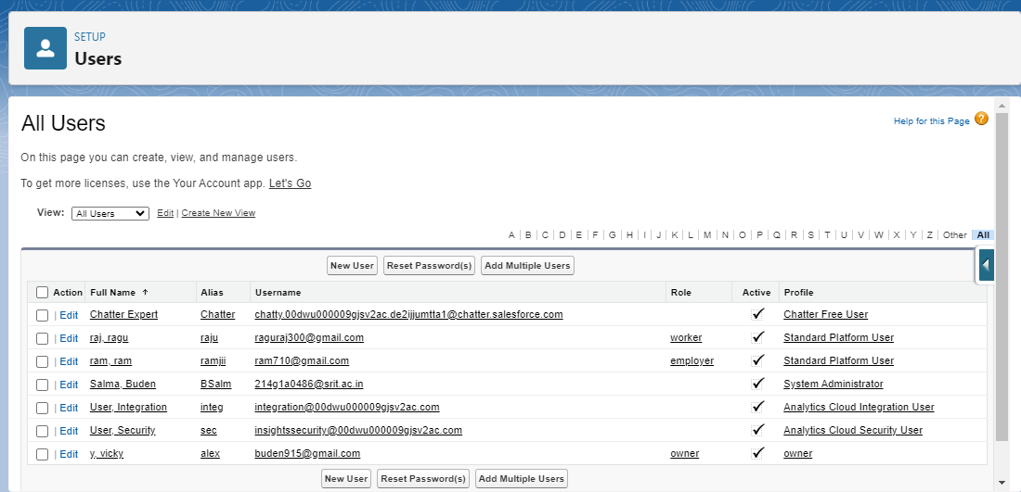

Fig : Users

**Permission sets**

A permission set is a collection of settings and permissions that give users access to various tools and functions. Permission sets extend users’ functional access without changing their profiles and are the recommended way to manage your users’ permissions.

**Steps to Create a Permission Set:**

1. **Navigate to Permission Sets**:
   * Click on the **Gear icon** (⚙️) in the upper-right corner of the Salesforce page.
   * Click **Setup**.
   * In the **Quick Find** box, type **Permission Sets**.
   * Click **Permission Sets** under the **Users** section.
2. **Create a New Permission Set**:
   * In the **Permission Sets** page, click the **New** button.
   * **Label**: Enter a name for the permission set (e.g., Rice Mill Data Access, Advanced Reporting).
   * **API Name**: This will auto-populate based on the label, but you can modify it if needed.
   * **License**: Choose the appropriate license (or leave it set to --None-- to make it available to any user).
   * Click **Save**.
3. **Define Permissions in the Permission Set**:
   * After creating the permission set, you’ll be directed to a list of different settings you can customize for it.

**Key Permissions to Customize:**

* **App Permissions**:
  + Go to **App Permissions** to grant access to apps, such as custom **Lightning Apps** you've created (e.g., Rice Mill Management).
* **Object Settings**:
  + Click on **Object Settings** to manage access to **Custom Objects** like Rice Mill, Supplier, Consumer, and Rice Details.
  + You can grant permissions such as **Read**, **Create**, **Edit**, and **Delete** for each object.
* **Field Permissions**:
  + Under **Object Settings**, click on each object (e.g., Rice Details) to manage **Field-Level Security**.
  + Specify whether users with this permission set can view or edit specific fields (such as Price per Ton or Stock Quantity).
* **Tab Settings**:
  + Use the **Tab Settings** to control whether tabs are visible to users with this permission set. You can set them to **Default On**, **Default Off**, or **Hidden**.
* **System Permissions**:
  + In the **System Permissions** section, you can assign broader permissions like **View All Data**, **Modify All Data**, or more specific permissions like **Run Reports** or **Manage Dashboards**

**Report:**

Creating reports in Salesforce allows you to analyze data and gain insights into various aspects of your organization. Reports can be tailored to show specific data related to your rice mill operations, such as supplier performance, rice stock levels, or consumer purchases. Here's a guide on how to create and manage reports in Salesforce:

**Steps to Create a Report in Salesforce:**

**1. Navigate to the Reports Tab:**

* Click on the **App Launcher** (the grid icon) in the upper-left corner.
* Search for and select **Reports**.

**2. Create a New Report:**

* Click the **New Report** button.
* You will see a dialog box that prompts you to select a report type.

**3. Select a Report Type:**

* Choose the appropriate report type based on the object you want to report on (e.g., Rice Details, Supplier, or Consumer).
* Click **Continue**.

**4. Design Your Report:**

* **Report Builder**: You will be taken to the report builder interface where you can customize your report.
* **Fields Panel**: On the left side, you'll see the fields available for the selected report type.
* **Add Fields**: Drag and drop fields from the panel to the report preview area. For example:
  + **For Rice Details Report**: Add fields like Rice Type, Stock Quantity, Price per Ton, and Harvest Year.
  + **For Supplier Report**: Include fields like Supplier Name, Location, and Contact Information.

**5. Configure Report Format:**

* **Report Format**: Choose the format of your report:
  + **Tabular**: A simple list of records (best for a flat data presentation).
  + **Summary**: Allows you to group rows of data and display subtotals (useful for data analysis).
  + **Matrix**: Displays data in a grid format, allowing you to group data by rows and columns.
  + **Joined**: Combines multiple report types in one report (advanced usage).

**6. Group Data (if using Summary or Matrix):**

* Drag a field into the "Group Rows" area to create groups in your report.
* For example, to analyze rice stock by Rice Type, drag Rice Type to the group rows area.

**7. Add Filters:**

* Use the **Filters** panel on the left to narrow down the data displayed in your report.
* Set criteria to filter data, such as showing only records where Stock Quantity is greater than 100 or Supplier is a specific name.

**8. Add Charts (Optional):**

* You can add charts to visualize data:
  + Click on the **Chart** icon in the report builder.
  + Choose a chart type (bar, pie, line, etc.) and configure it based on your grouped data.

**9. Run the Report:**

* Click the **Run** button to generate your report.
* Review the report results to ensure it meets your needs.

**10. Save the Report:**

* Click **Save & Run**.
* Give your report a name (e.g., Rice Stock Report, Supplier Performance Report).
* Optionally, add a description to explain the report's purpose.
* Choose a folder where you want to save the report (private, shared, etc.).
* Click **Save**.

**Dashboards:**

Salesforce **Dashboards** provide a visual representation of your data using charts, graphs, and other components. Dashboards allow you to monitor key metrics and gain insights at a glance, which is especially useful for tracking the performance of your rice mill, suppliers, inventory, and other business metrics.

Here’s a guide on how to create and customize dashboards in Salesforce:

**Steps to Create a Dashboard in Salesforce:**

**1. Navigate to Dashboards:**

* Click on the **App Launcher** (the grid icon) in the upper-left corner of the Salesforce interface.
* Search for and select **Dashboards**.

**2. Create a New Dashboard:**

* Click the **New Dashboard** button in the upper-right corner.
* **Dashboard Name**: Enter a name for your dashboard (e.g., Rice Mill Performance, Inventory Overview).
* **Folder**: Select or create a folder to store the dashboard. You can choose between private or shared folders.
* **Description**: Optionally, add a description to describe the purpose of the dashboard.
* Click **Create**.

**3. Add Components to the Dashboard:**

After creating the dashboard, you’ll be taken to the dashboard editor, where you can add and configure components.

* **Click Add Component** to start adding visualizations.
* Choose the type of component you want to add (e.g., charts, gauges, metrics, tables).
* Select a report to use as the data source for the component (you need to have pre-existing reports for this step).

**4. Choose a Report:**

* In the **Component** tab, select the report that contains the data you want to visualize (e.g., a report on Rice Details, Supplier Performance, or Consumer Purchases).
* Once the report is selected, the available data will be displayed.

**5. Configure the Component:**

* **Chart Type**: Choose the type of visualization (e.g., bar chart, pie chart, line chart, etc.) depending on the data you want to represent.
* **Component Title**: Give the component a meaningful title (e.g., Stock Levels by Rice Type, Top Performing Suppliers).
* **Data Settings**: Configure how the data will be displayed, such as grouping or filtering criteria.
* Click **Add** to include the component in your dashboard.

**6. Add More Components:**

* Repeat the process of adding components to represent different aspects of your business (e.g., rice stock, supplier performance, consumer purchases).
* You can move and resize components on the dashboard layout to optimize space.

**7. Save and Run the Dashboard:**

* Once you've added all the components, click **Save**.
* Click **Done** to finish the dashboard setup.
* The dashboard will display the latest data from the reports you've selected.

Salesforce Dashboards are powerful tools for monitoring and visualizing key metrics for your rice mill business. By using a combination of reports, filters, and dynamic components, you can create insightful dashboards that help you track performance, manage inventory, monitor supplier efficiency, and much more. Dashboards also enable you to stay updated with scheduled or dynamic updates for real-time insights.

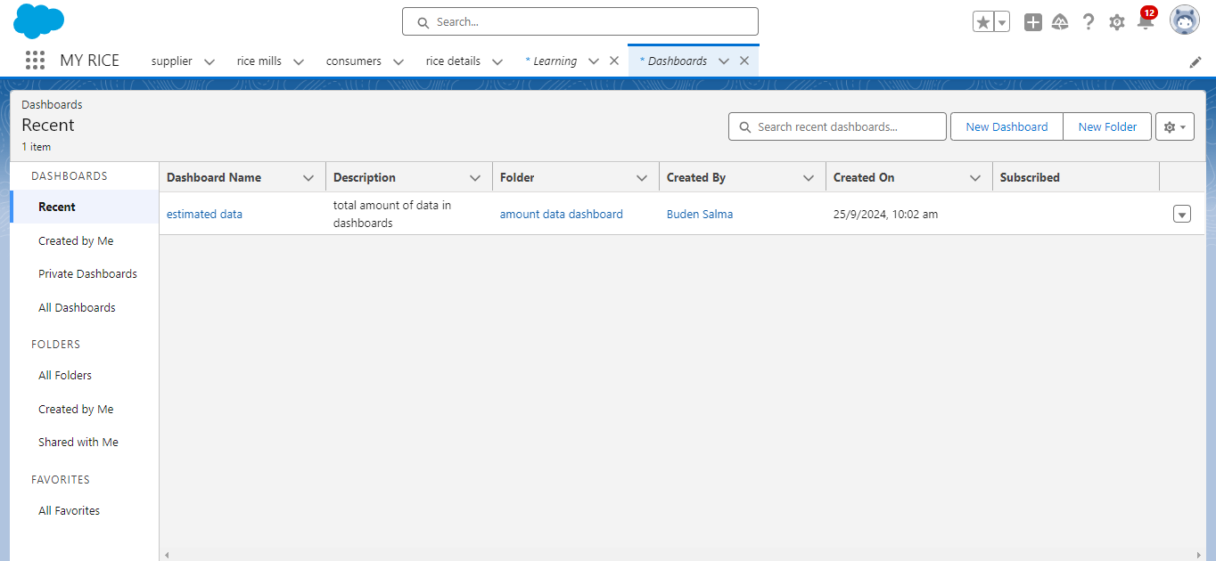

Fig : Dashboard

**APEX**

Apex is a strongly typed, object-oriented programming language that allows developers to execute flow and transaction control statements on the Lightning platform server in conjunction with calls to the Lightning Platform? API. Using syntax that looks like Java and acts like database stored procedures, Apex enables developers to add business logic to most system events, including button clicks, related record updates, and Visualforce pages. Apex code can be initiated by Web service requests and from triggers on objects.

It is as similar as java i.e, it also supports OOP( Object oriented programming) like Classes, objects, methods.

**Writing Apex Code in Salesforce:**

**Navigate to the Developer Console**:

* + Click on the **Gear icon** (⚙️) in the upper-right corner of Salesforce.
  + Select **Developer Console**. This is where you can write, test, and debug your Apex code.

**Basic Apex Class Structure**: Apex classes consist of methods (functions) and properties.

**Apex Trigger Example**: A trigger runs automatically when a specified event (like an insert or update) occurs on a particular Salesforce object.

**SOQL (Salesforce Object Query Language)**: You can query Salesforce data using SOQL, which is similar to SQL.

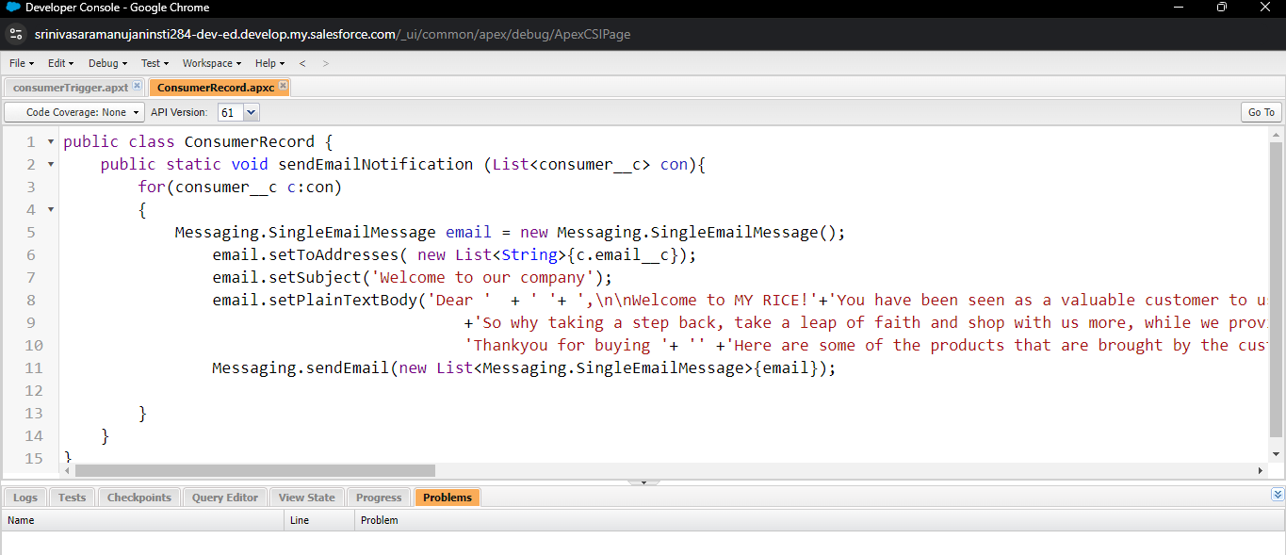

**Apex Class**

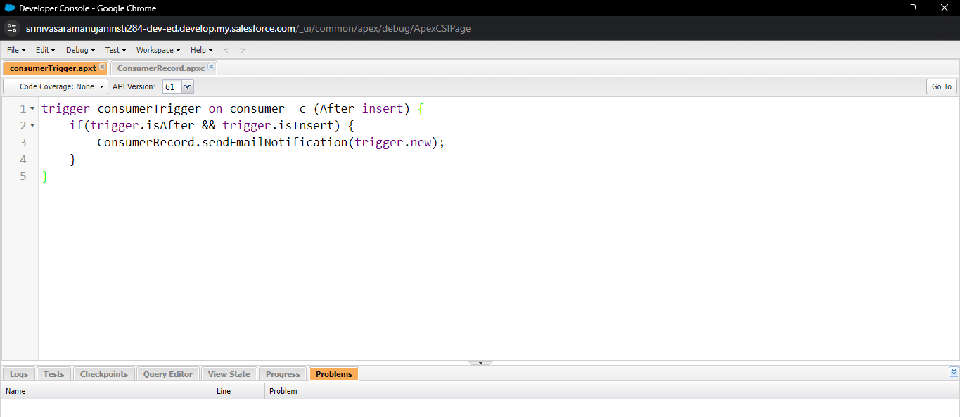

**Apex Trigger**

**DML (Data Manipulation Language) Operations**: Apex supports DML operations to insert, update, delete, or upsert records in the database.

**Apex Batch Class**: If you need to process large sets of data, use batch Apex.

**Apex Callouts**: Use Apex to make HTTP callouts to external APIs.

**Test Classes**: Every Apex code written in Salesforce should have corresponding test classes to ensure the code functions properly and meets test coverage requirements (usually 75% coverage).

Apex allows you to add powerful custom business logic to your Salesforce instance, which can be tailored to your rice mill operations or any other business need. You can use triggers, classes, batch processing, and integrations to create sophisticated customizations that streamline workflows and automate tasks.

**Conclusion :**

The **Rice Mill CRM** project in Salesforce successfully establishes a comprehensive system to streamline and manage the operations of a rice mill. By leveraging Salesforce’s capabilities, we have created a highly customized solution that supports core business functions, enhances operational efficiency, and provides valuable insights for informed decision-making.

**THANK YOU**